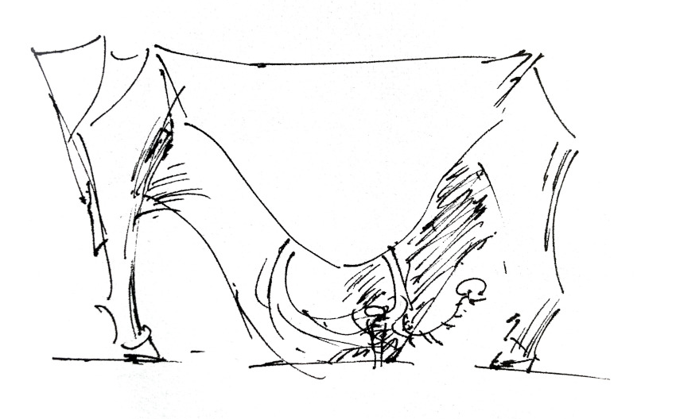
Peter Linnett's
Imagined Creatures
to debut at
Fuorisalone Milano 2025
This show marks the Milan debut for the Scottish sculptor/designer, who’s work features in private and museum collections in China, Europe and USA.
Press Release
Peter Linnett’s statement furniture series "Imagined Creatures" is a project which has been quietly taking form over a period of some 20 years.
The first pieces in the series emerged in the early 2000’s from Linnett’s East London studio - where they jostled for attention alongside an eclectic mix of custom projects for high-end interiors and fine antiques undergoing restoration. The cross-pollination from period design styles was always clearly apparent: Linnett’s sculptural furniture resonates with - and belongs within - a timeless historical lineage.
In 2019, frustrated with what he saw as the soulless over-refined character of most high-end design, he took the decision to break with the mainstream luxury industry, and take his furniture work decisively into the realm of what he calls “anti-perfection”. This explicit acknowledgement of a value which had long been at the heart of his work, coincided with a decision to relocate his studio to the city of Edinburgh, in his native Scotland.
Linnett articulated his creative philosophy in a talk he gave to the China International Interior Design Association (CIID88) in Beijing in 2019:
“Flawless products once emerged only from the hands of the most skilled artisans; but modern manufacturing techniques have rendered perfection mundane… …artisans must now focus on asserting their humanity, and stop vying with machines in a hankering for perfection”
Work from the Edinburgh studio, which recently featured in the Visual Arts Scotland centenary show at Dalkeith Palace, sees a switch from the opulent material palette which was a hallmark of his London work; with reclaimed timber (in the form of scaffolding planks) taking over as the dominant material. The forms, however, far transcend the austerity of the material. The decaying and abused timber serves to provide a deep underlying patina reminiscent of a well-worn heirloom antique. Despite the material frailty, the forms are powerfully robust and characterful; channelling the energy and essence of the mythical creatures after which they are named:- Minotaur. Centaur.
Some earlier pieces from Imagined Creatures will also be presented in the Milan show:- a bronze table - Unicorn - which, alongside Linnett’s headline-grabbing Dragon chaise-longue, is now in the collection of the XiangSi Design Museum in Tianjin, China; and a bull from Zeus and the Herd - a series of chairs in which the Greek god Zeus conceals himself within a herd of cattle.
The works will be presented in the spacious interior of a former factory building within Milan’s historic Tortona district - one of the key destinations for visitors to Fuorisalone. The exhibition will be open daily from 7-13 April 2025.

Why “Imagined Creatures”? The Artist Explains
My work doesn’t just resound with historical references; it initiates its own narratives, destined to reverberate long into the future.
Buried within the form and construction of these furniture pieces are conscious expressions, both of the process of production, and of the nature of the materials. And there is an invitation - implicit in the not-quite-finished, yet already degraded condition in which they are presented - to further build out these narratives as an ongoing story.
To this, I have added the whimsy of associating each piece with a mythical creature; thus placing it at the mercy of a loose aural storytelling tradition which evolves and mutates, so can never be pinned to a definitive storyline.

Peter Linnett / Imagined Creatures
dates:
07 April 2025 – 13 April 2025
open daily, 10:00-18:00
location:
via Tortona 26, Milano (Tortona)
Metro: Porta Genova
press enquiries (Peter Linnett):
Peter Linnett: peter@peterlinnett.com / +44 7703 246 446
press enquiries (Tortona Design District):
Chiara Giudici: c.giudici@doublemalt.it / +39 338.8971323
Press Images
Available to download at www.peterlinnett.com/pr-fuorisalone-25-en
Other images available on request from: peter@peterlinnett.com
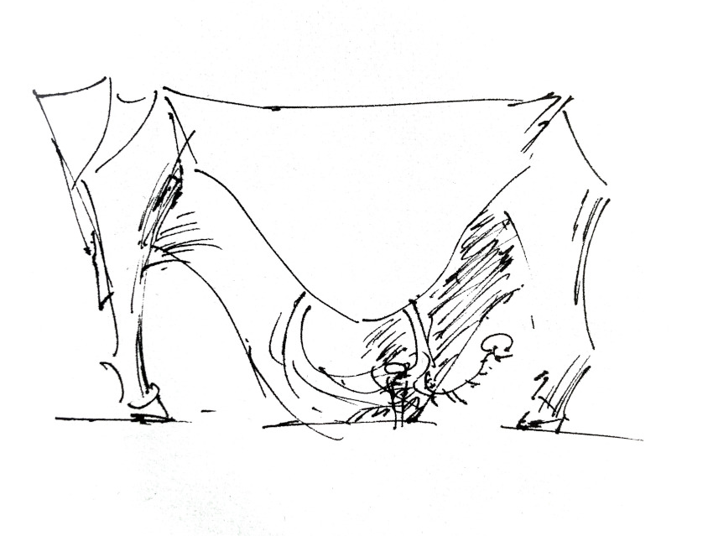  Minotaur (console table) / sketch: Peter Linnett | 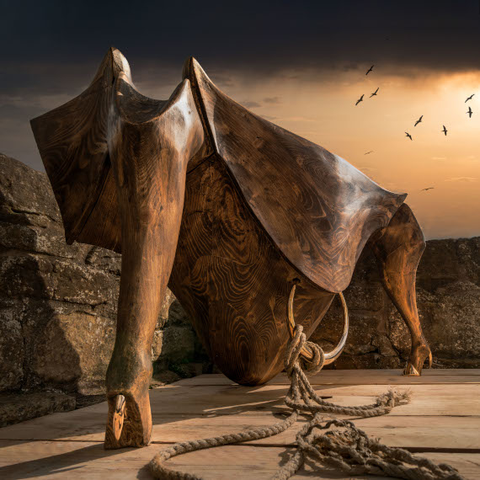  Minotaur (console table) / photo: Graeme Houston
  Centaur (writing desk) /photo: Ian Coyle | 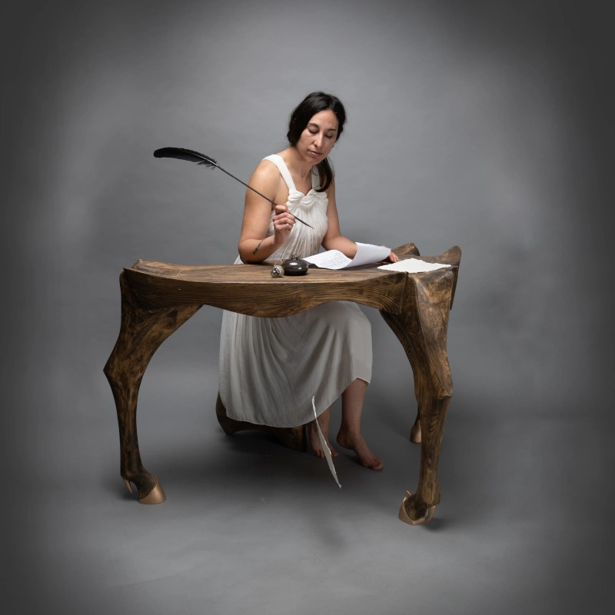  Centaur (writing desk) /photo: Ian Coyle
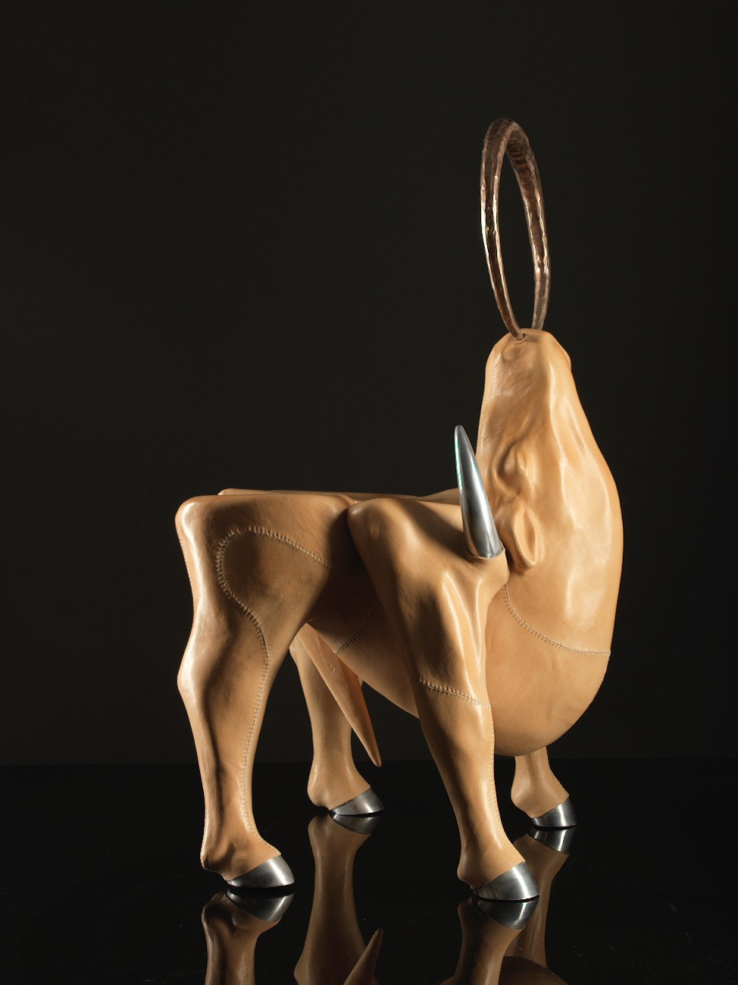  Zeus Bull (chair) / photo: Tony Hutchings | 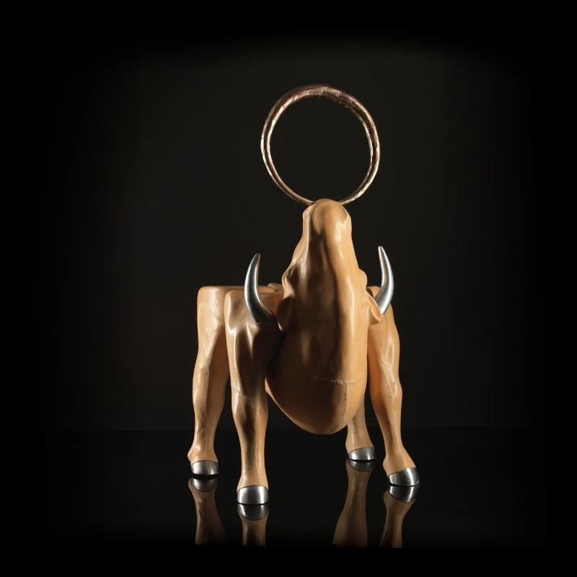  Zeus Bull (chair) / photo Tony Hutchings
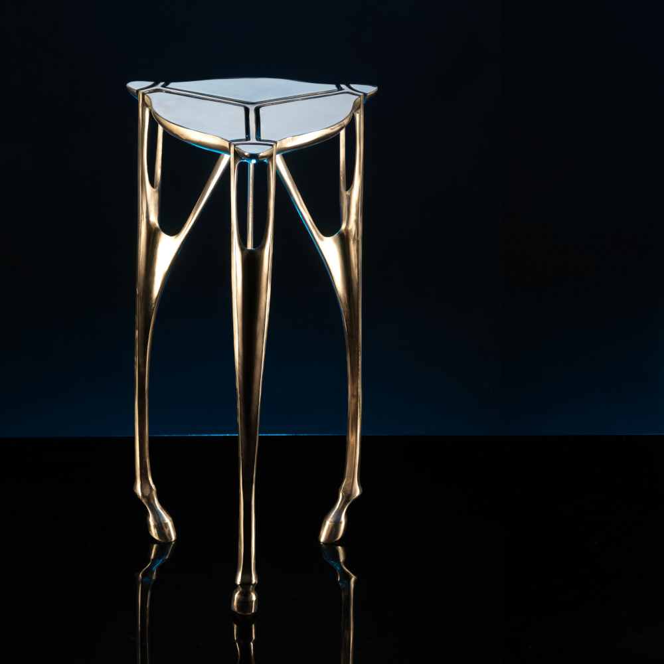  Unicorn (table) / photo: Tony Hutchings | 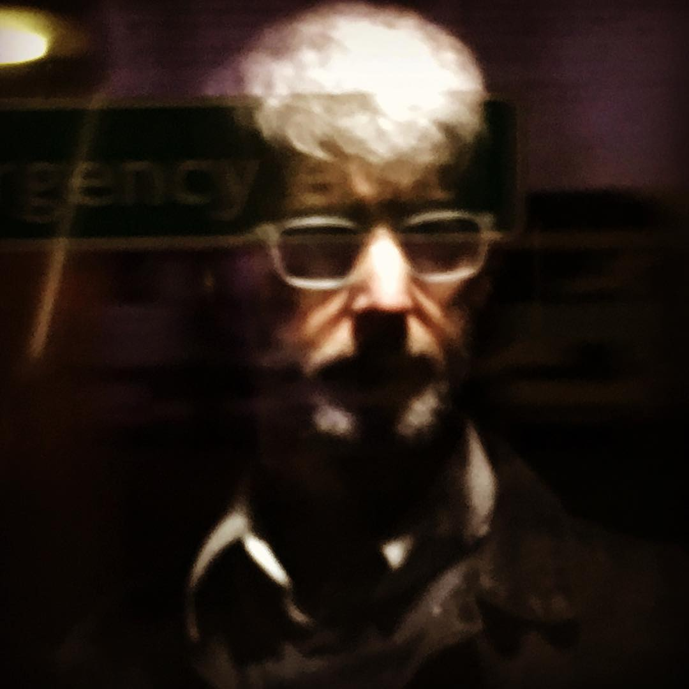  Peter Linnett / photo: Peter Linnett

Alongside his work as a sculptor, Linnett also worked as consultant in restorations and client projects for prestige antique dealer Westland London, and as a design project manager at luxury interiors contractor DKT Artworks Ltd.
Address to the CIID88 International Design Summit, Beijing, August 2019.

